**Depth Study One – Speed Racers (5 hours)**

In this Depth Study you will be designing, building and modifying a Speed Racer to travel in a straight line.

You will then either be modifying, or rebuilding to make an even faster Speed Racer.

**Depth Study Requirements:**

**Collaboration** – Teams of 3. Work together as a team, however each student is to complete their own report.

**Time** – 5 hours of in-class time allocated

**Equipment** – Speed Racer Kit per group. Three 1.5 volt motors, 3 fan blades, 4 plastic wheels, battery packs with batteries, 10 paddlepop sticks, 2 kebab sticks, 4 straws, a piece of core flute and a hot glue gun with 2 hot glue sticks.

**Working Scientifically –** Questioning and Predicting PH11/12-1

**Working Scientifically –** Communicating PH11/12-7

**Working Scientifically –** Conducting Investigations PH11/12-3

**Working Scientifically –** Processing Data and Information PH 11/12-4

**Knowledge and Understanding** – describes and analyses motion in terms of scalar and vector quantities in two dimensions and makes quantitative measurements and calculations for distance, displacement, speed, velocity and acceleration PH11-8

1. Using the kit, first design and then construct a speed racer which travels as close as possible to a *straight line*. (45 minutes)

Insert Design Drawing Insert Photo of Speed Racer



2. Trial the Speed Racer and discuss how well it travels in a straight line. Use a measuring tape and metre ruler to *quantify* your discussion*.* (15 minutes)

_______________________________________________________________________________________

_______________________________________________________________________________________

_______________________________________________________________________________________

3. **Working Scientifically – Questioning and Predicting** (15 minutes)

What are some of the factors which cause your Speed Racer to NOT travel in a straight line?

i)______________________________________________________________________________________

ii)_____________________________________________________________________________________

What improvements could you make to your Speed Racer to improve its ability to travel in a straight line?

i)______________________________________________________________________________________

ii)_____________________________________________________________________________________

4. Make the improvements on your Speed Racer. (15 minutes)

Insert new photo of Speed Racer



5. **Working Scientifically – Communicating** (15 minutes)

Trial the modified Speed Racer and discuss how well it travels in a straight line. Use a measuring tape and metre ruler to *quantify* your discussion*.*

_______________________________________________________________________________________

_______________________________________________________________________________________

_______________________________________________________________________________________

6. Discuss the effectiveness of improvements you made to your Speed Racer to improve its ability to travel in a straight line? (10 minutes)

i)______________________________________________________________________________________

ii)_____________________________________________________________________________________

7. Research what is meant by *average velocity*. Reference your research. (15 minutes)

8. **Working Scientifically – Conducting Investigations** (10 minutes)

**Knowledge and Understanding – develop knowledge and understanding of fundamental mechanics**

Determine the average velocity of your speed racer over 6 metres.

|  |  |  |
| --- | --- | --- |
| Trial | Time (s) | Average Velocity (ms-1) |
| 1 |  |  |
| 2 |  |  |
| 3 |  |  |
| Average |  |  |

9. Release your Speed Racer from the point of origin and time how long it takes to reach 1m, 2m, 3m, 4m, 5m and 6m. Repeat in order to get an average for each distance. (15 minutes)

|  |  |  |  |
| --- | --- | --- | --- |
| Distance (m) | Time (s) | | |
| 1 | 2 | Average |
| 0 | 0 | 0 | 0 |
| 1 |  |  |  |
| 2 |  |  |  |
| 3 |  |  |  |
| 4 |  |  |  |
| 5 |  |  |  |
| 6 |  |  |  |

10. Plot a graph of Distance(m) verses Time(s) using the data collected. (15 minutes)

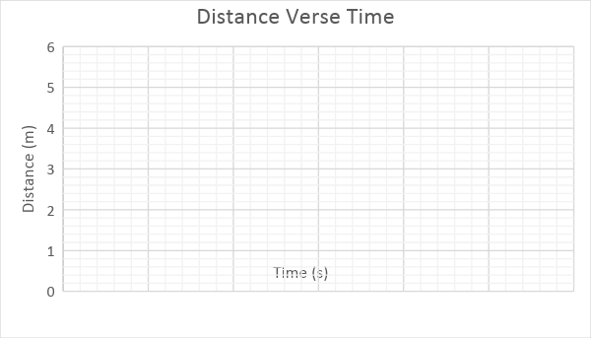

11. Research what is meant by instantaneous velocity. Reference your research. (15 minutes)

12. **Working Scientifically – Processing Data and Information** (10 minutes)

Using your graph, discuss your Speed Racer’s instantaneous velocity over the 6 metre journey.

Hint: The gradient of the graph at each point in time gives the instantaneous velocity.

Zero velocity low velocity high velocity



13. Use your graph to find the Speed Racer’s maximum instantaneous velocity. Show your working. (10 minutes)

14. A changing instantaneous velocity means the vehicle is accelerating. Discuss your Speed Racer’s acceleration over the 6 metres. (10 minutes)

15. Modify or rebuild your Speed Racer so that it travels faster. (30 minutes)

Insert Design Drawing Insert Photo of Speed Racer



16. Determine the average velocity of your speed racer over 6 metres. (10 minutes)

|  |  |  |
| --- | --- | --- |
| Trial | Time (s) | Average Velocity (ms-1) |
| 1 |  |  |
| 2 |  |  |
| 3 |  |  |
| Average |  |  |

17. Release your Speed Racer from the point of origin and time how long it takes to reach 1m, 2m, 3m, 4m, 5m and 6m. Repeat in order to get an average for each distance. (15 minutes)

|  |  |  |  |
| --- | --- | --- | --- |
| Distance (m) | Time (s) | | |
| 1 | 2 | Average |
| 0 | 0 | 0 | 0 |
| 1 |  |  |  |
| 2 |  |  |  |
| 3 |  |  |  |
| 4 |  |  |  |
| 5 |  |  |  |
| 6 |  |  |  |

18. Plot a graph of Distance(m) verses time(s) using the data collected.

On the same graph, plot your data for your original Speed Racer. (15 minutes)

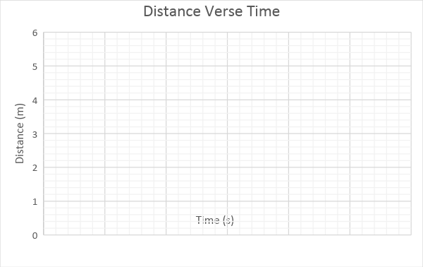

19. Discuss the similarities and differences between the Average Velocities and the Instantaneous Velocities between the two Speed Racers. (15 minutes)

**Depth Study One – Speed Racers – Marking Rubric** Name____________________________

|  |  |  |  |  |
| --- | --- | --- | --- | --- |
| Question | Extensive | Thorough | Sound | Basic |
| 1. Design and Construct | Scaled, clear drawing.  Likely to travel straight line.  Model same as design. | Clear drawing.  Likely to travel straight line.  Model similar to design. | Drawing.  May travel in straight line.  Model representative of design. |  |
| 2. Trial and discussion regarding straight line travel | Qualitative and Quantitative.  Detailed description. | Qualitative and Quantitative. | Qualitative. |  |
| 3. Straight line analysis and improvements | Detailed and thoughtful.  Improvements address causes. | Detailed.  Improvements. | General description.  An improvement. |  |
| 4. Improved Speed Racer | Well executed improvements which match plan. | Improvements matching plan. | Improved. |  |
| 5. Trial and discussion regarding straight line travel | Qualitative and Quantitative.  Detailed description. | Qualitative and Quantitative. | Qualitative. |  |
| 6. Discussion of effectiveness of improvements | Thougtful, detailed, correlated discussions. | Thoughtful, detailed discussion. | Discussed. |  |
| 7. Average Velocity Research | Referenced, detailed and including equation and example. | Referenced, detailed and including equation. | Detailed. |  |
| 8. Average Velocity results | Complete and accurate table. | Completed table. | Mostly completed table. |  |
| 9. Position and Time results | Complete and accurate table. | Completed table. | Mostly completed table. |  |
| 10. Distance verse Time graph | Points plotted accurately with x’s.  Smooth line of best fit  Appropriate Time scale | Most aspects correct | Some aspects correct |  |
| 11. Instantaneous Velocity Research | Referenced, detailed and including equation and example. | Referenced, detailed and including equation. | Detailed. |  |
| 12. Instantaneous Velocity Discussion | Qualitative, quantitative and extensive | Qualitative and quantitative | Qualitative |  |
| 13. Maximum Instantaneous Velocity | Very accurate | Accurate | Determined |  |
| 14. Acceleration discussion | Qualitative, quantitative and extensive | Qualitative and quantitative | Qualitative |  |
| 15. Modified Speed Racer | Scaled, clear drawing.  Likely to travel faster  Model same as design. | Clear drawing.  Likely to travel faster.  Model similar to design. | Drawing.  May travel faster.  Model representative of design. |  |
| 16. Average Velocity results | Complete and accurate table. | Completed table. | Mostly completed table. |  |
| 17. Position and Time results | Complete and accurate table. | Completed table. | Mostly completed table. |  |
| 10. Distance verse Time graph | Points plotted accurately with x’s.  Smooth lines of best fit  Appropriate Time scale | Most aspects correct | Some aspects correct |  |
| 19. Comparison discussion of Speed Racers | Qualitative, quantitative and extensive | Qualitative and quantitative | Qualitative |  |

Overall comment ________________________________________________________________________

3 Blade propeller

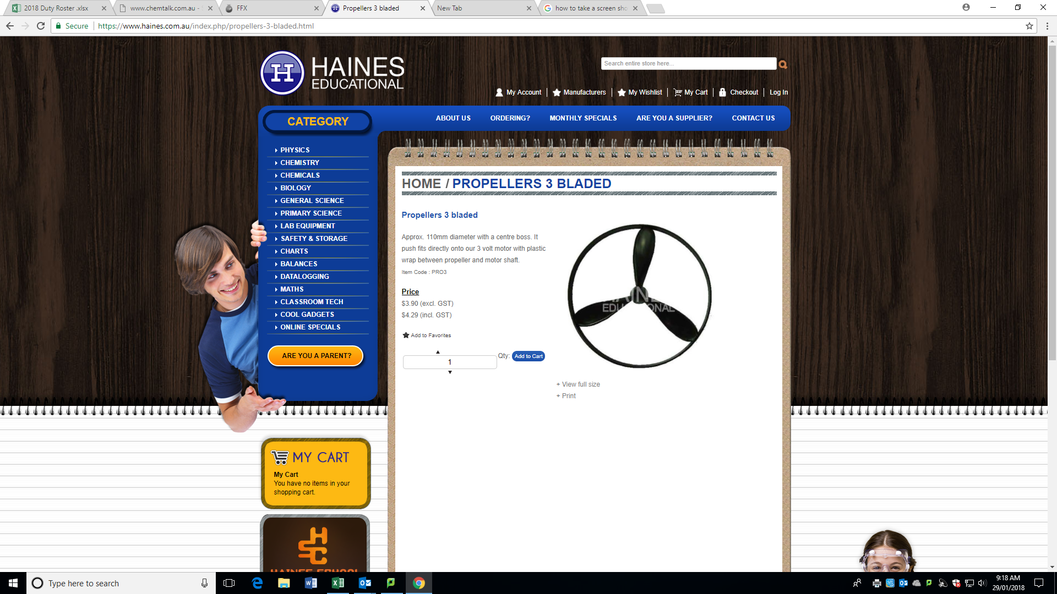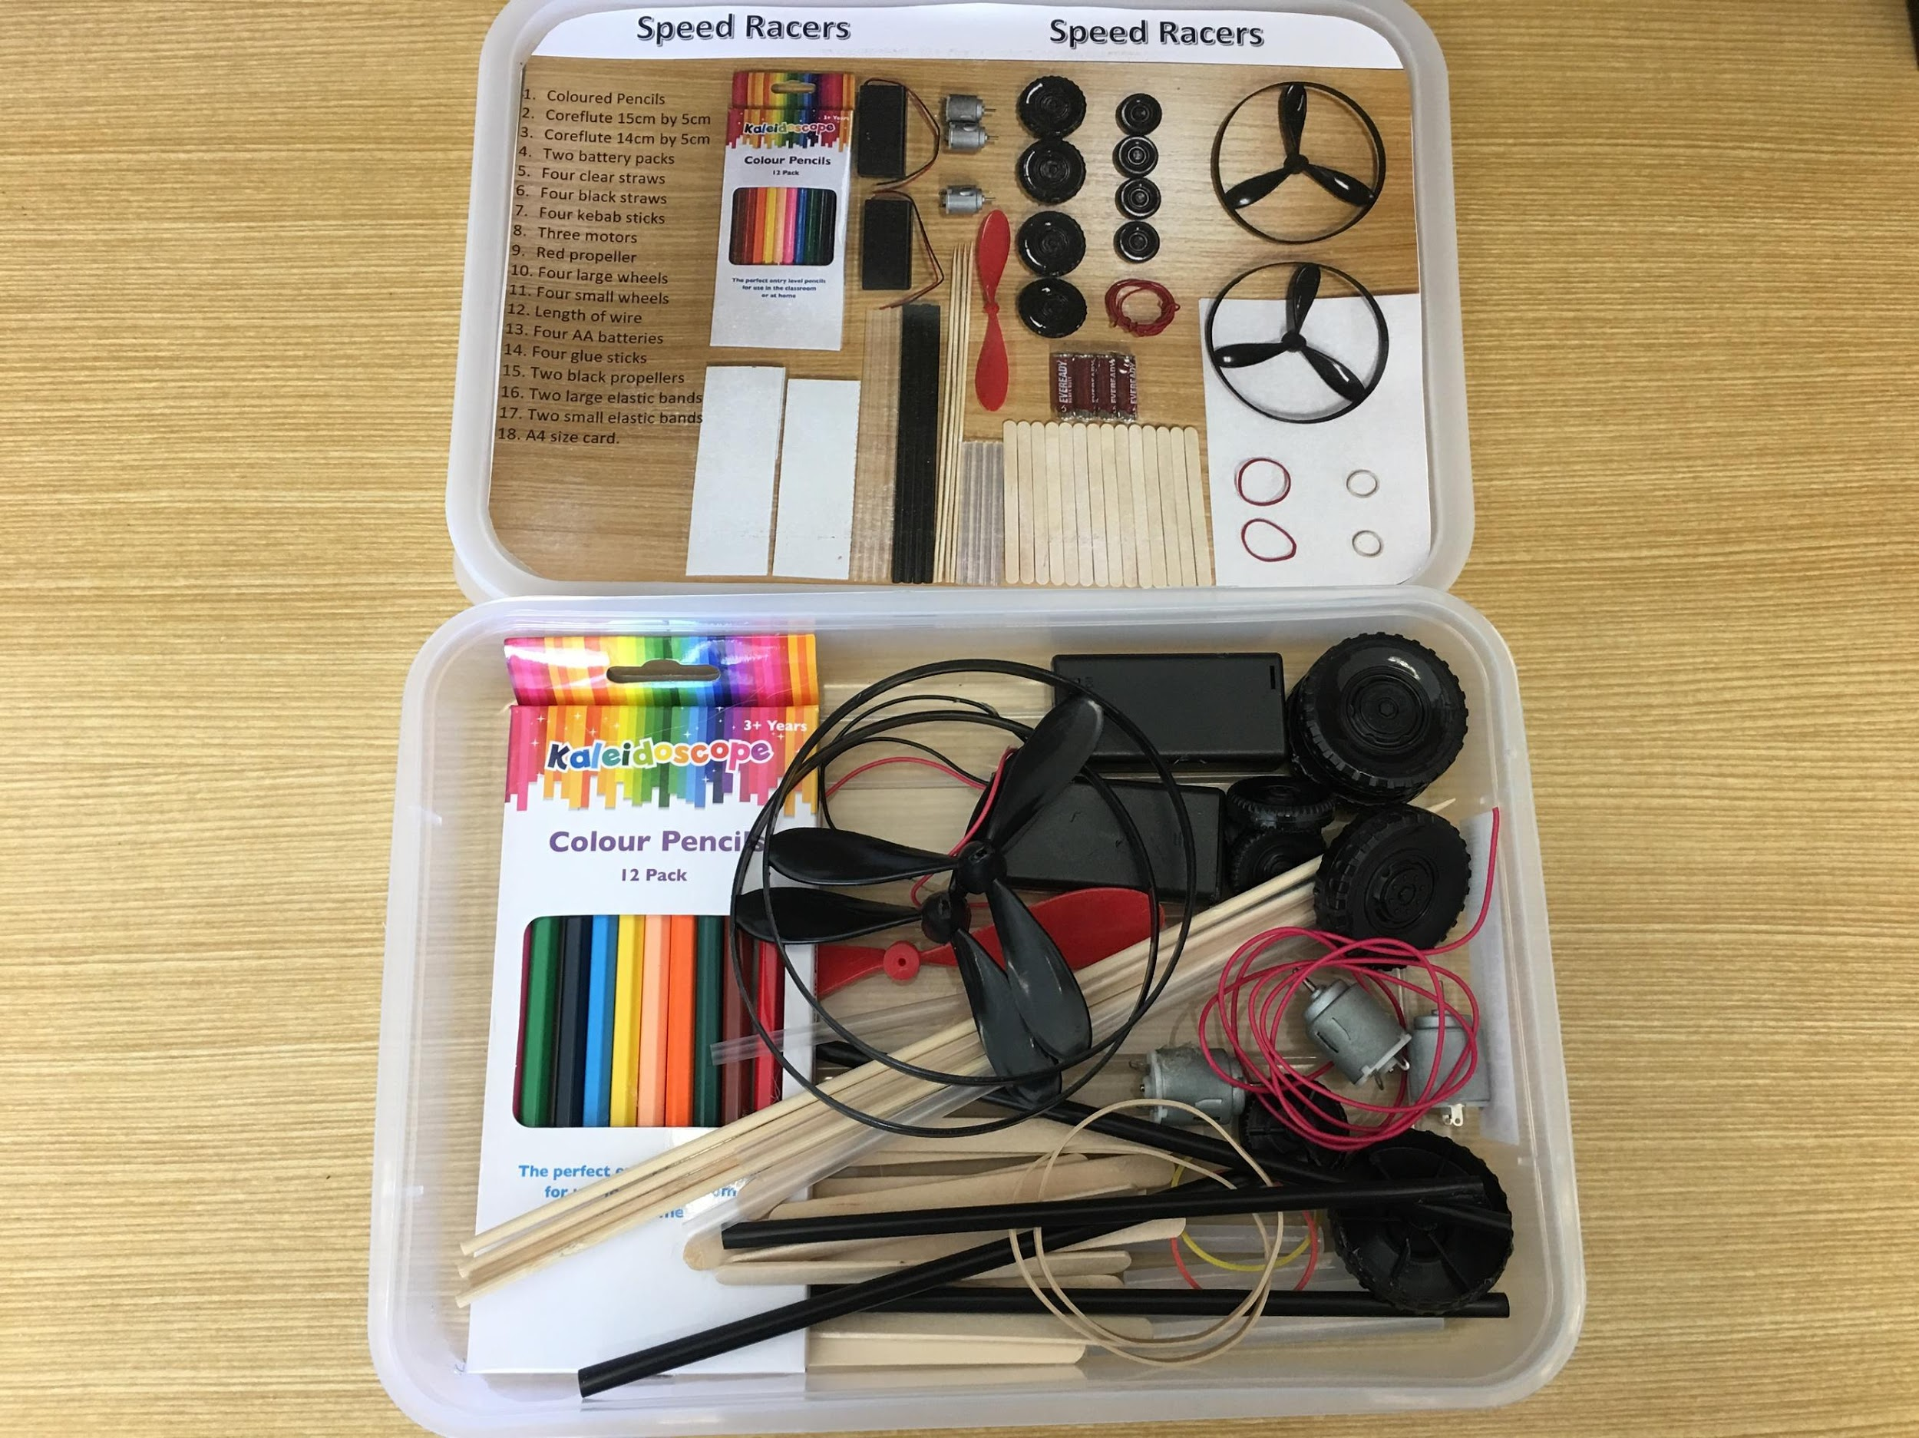

Small motors

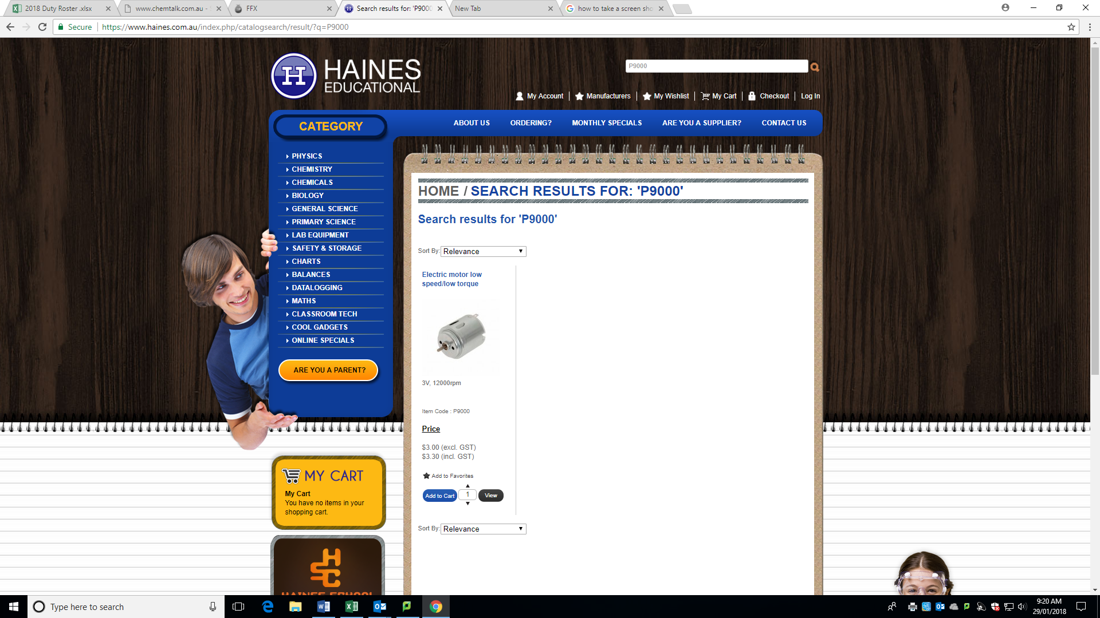

Address

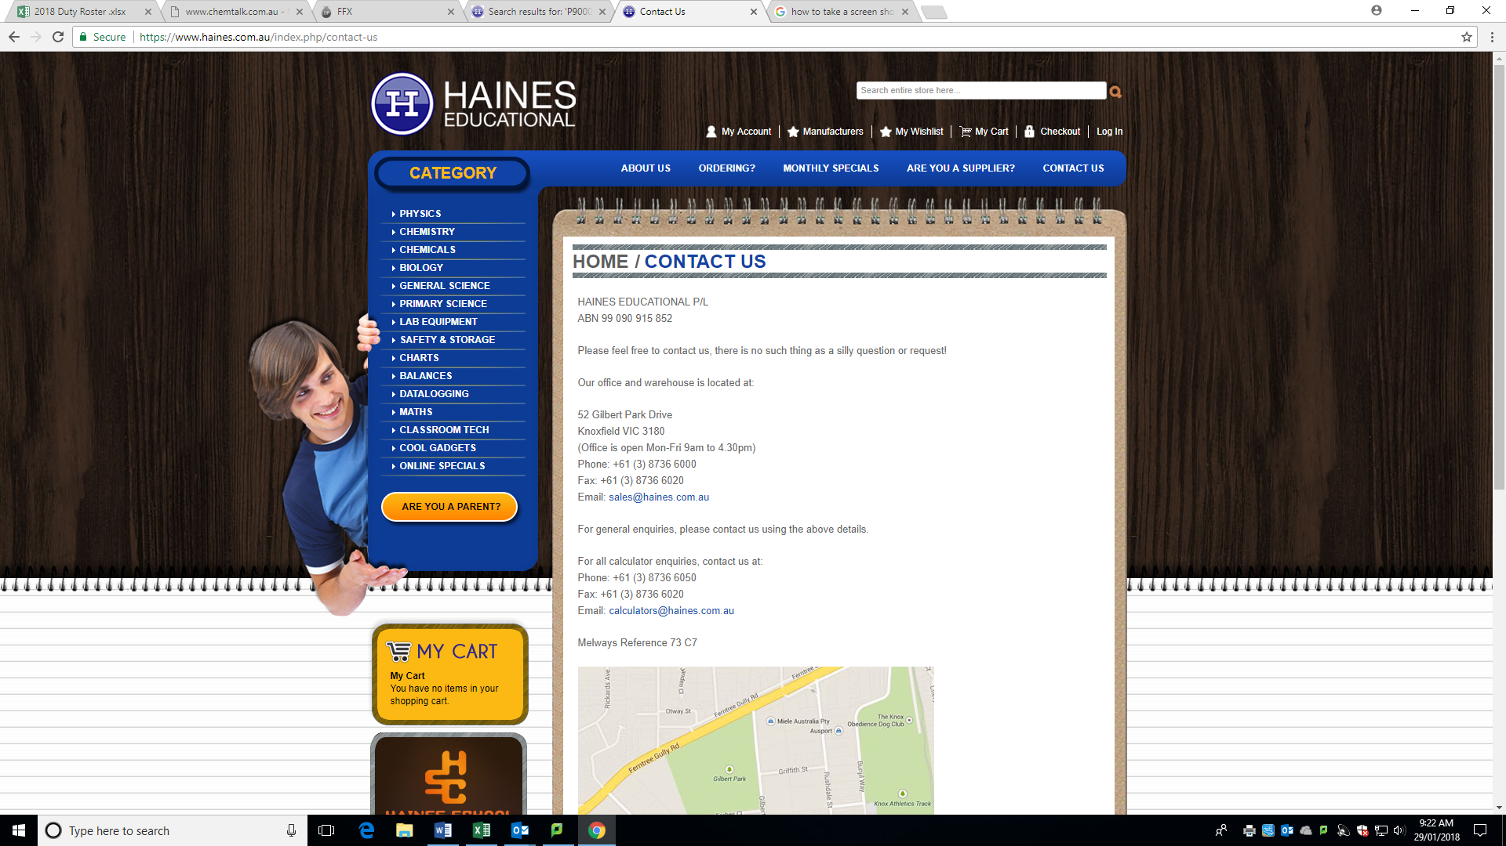

Two bladed propeller blade and wheels also from Haines and also Kookaburra

Motors can also be bought at Serrata.